Food Web Computer Simulation
Student Name
Professors Name
Institution Affiliation

Food Web Computer Simulation
Part I
Step 1: Straight Line Food chain
Plant B Herbivore B Omnivore B Top Predator
In this straight-line food chain, Plant B is eaten by Herbivore B, Herbivore be is eaten Omnivore B and Omnivore B is eaten by the predator. Below is the set up and simulation results up to 100 days in the ecosystem:
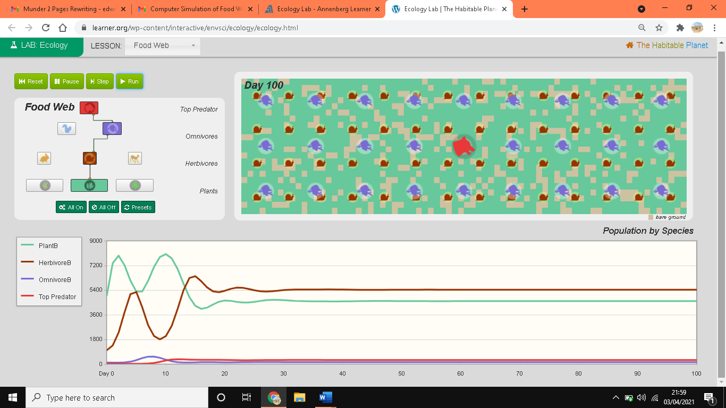
Step 2: Plant B survives on its own
When B survives on its own it implies that is not being fed on by any of the herbivores, omnivores and predator in the ecosystem.
Prediction Data Table:
Day | Plant B | Herbivore B | Omnivore B | Top predator
0 | - | - | - | -
40
80
120
160
200
240
280
320
360
400 | X

Hypothesis:
If plan B survives by its own, at day zero, it population will be constant. As the number of days increase, the population of the plants also increases. When the numbers of days reach 240, the population of plant b start declining and the plants B eventually will be eliminated from the ecosystem.
At day 0, the population of Herbivore B will be constant, as days increase to 80, the population of herbivore B decrease. Thereafter, the population of the herbivores B increase up to day 280, and becomes constant. Omnivore B and Top predator will demonstrate the same behaviour.
Simulation Result:
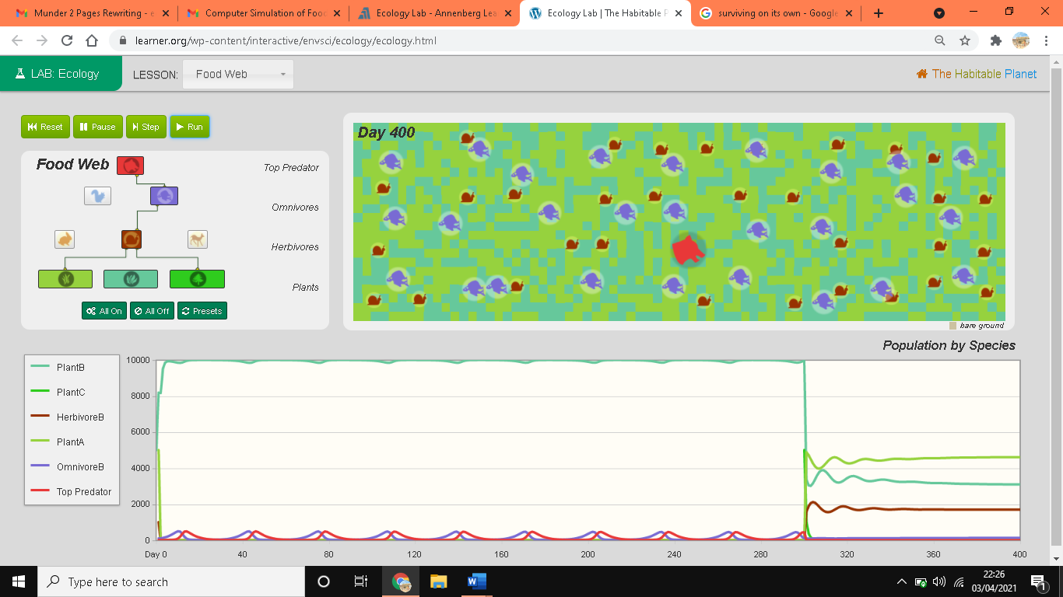
Q 1
My prediction was accurate. If plan B survives by its own, at day zero, its population will be constant since time has not changed. As the number of days increase, the population of the plantB increases because they are not fed on. When the numbers of days reach 240, the population of plant B start declining due to decline of nutrients. Eventually plants B will be eliminated from the ecosystem since the its high population would have consumed all the available nutrients.
Q 2
If producers die out, the consumers will decline and finally get eliminated hence the ecosystem will also be eliminated.
Q 3
Species increased in number at certain days. At day 0, the population of Herbivore B were constant since time had not changed. As days increased to 80, the population of herbivore B decreased since its producer, plant B had been withdrawn from the ecosystem. Thereafter, the population of the herbivores B increased up to day 280 due to adaptation to the environment, and above 280 days, the population of herbivores B remains constant because of ecosystem balance. Omnivore B and Top predator demonstrated the same behaviour as those herbivores.
Q 4
Producer, that is plants will benefit most. Decomposers facilitated the breakdown of death animal and plant materials into nutrients. Nutrients are useful for growth of plants.
Part II
Food web

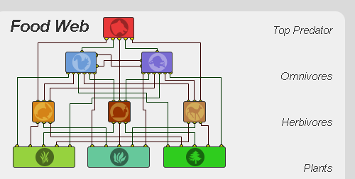
Prediction Data Table
Day | Plant A | Plant B | Plant C | Herbivore A | Herbivore B | Herbivore C | Omnivore B | Omnivore B | Top predator
0 |  | - | - | - | - | - | - | - | -
5
10
20 | constant |  |  |  |  |  |  |  | constant
30 |  |  |  |  |  |  |  | X | constant
40 |  |  |  |  |  |  |  | X | constant
50 |  |  |  |  |  |  |  | X | constant
60 |  |  |  |  |  |  |  | X | constant
70 |  |  |  |  |  |  |  | X | constant
80 |  |  |  |  |  |  |  | X | constant
90 |  |  |  |  |  |  |  | X | constant
100 |  |  |  |  |  |  |  | X | constant

At first the population of each producer and consumer remains constant. At five days, the population of producers, primary consumers and secondary consumers decline. At ten days, the population of producers slightly increased and declines at 20 days before becoming constant. Since the population of Omnivores B will be eliminated from the food web.

Result from Computer Simulation
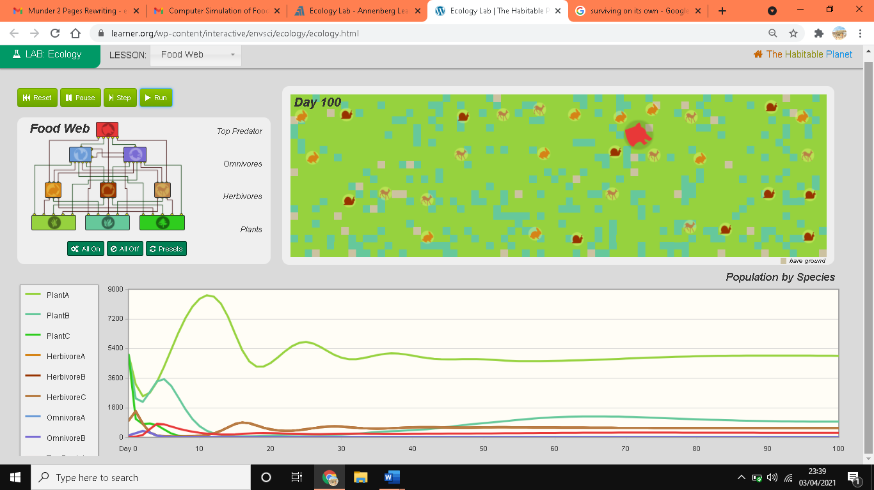
Q 1
My prediction was accurate. At day 0 the population of each producer and consumer remained constant since time had not changed. In five days, the population of producers, primary consumers and secondary consumers decline because of interdependency. At ten days, the population of producers slightly increased and declines at 20 days before becoming constant as due to adaptation. Omnivores B was eliminated from the food web due to its low population at the beginning.
Q 2
I tested each of the producers independently. I later tested the web with each of the herbivores independently and repeated the same with omnivores. At each test, the results were different but synonymous.
Q 3
Energy flows from producers to consumers then to producers as shown below:
Producers Primary consumers Secondary consumers Tertiary consumers Producers

Reference
Annenberg Foundation (2020). The Habitable Planet: A Systems Approach to Environmental Science. https://www.learner.org/series/the-habitable-planet-a-systems-approach-to-environmental-science/ecology-lab/. (Accessed: April 4th, 2021).

